For RENT - First Floor Apartment
1206 E. Vienna, Riverwest

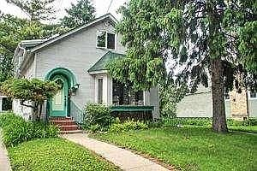
Available, Jan. 2021. 2 bedroom, 1 bath, basement storage and Washer/dryer, off street parking. View of Milwaukee River. $1,200/month, water included; gas, electricity, Internet shared with second floor tenant.

Email: amyo@uwm.edu Phone: 262-365-8543 (leave message)

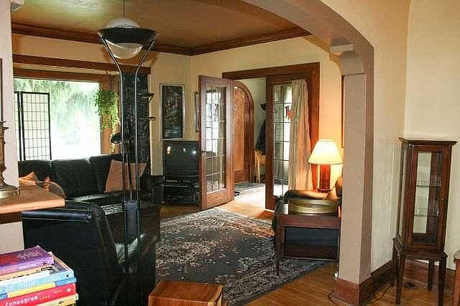 | 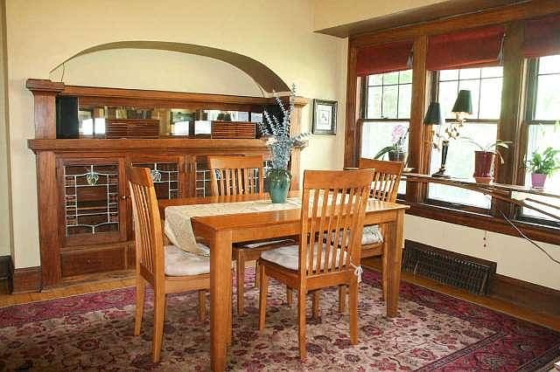
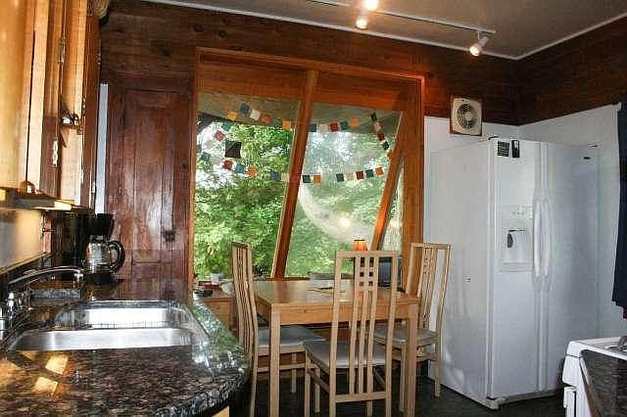 | 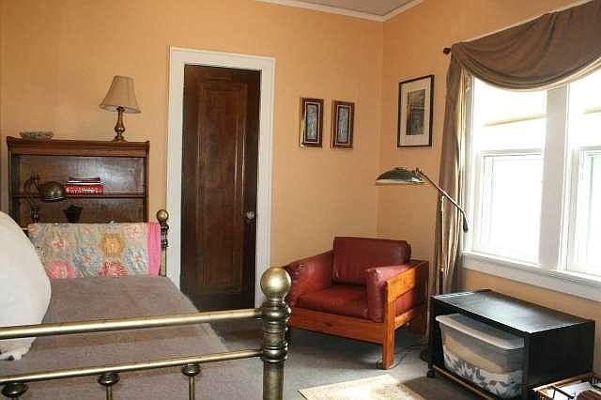

amyo@uwm.edu  262-365-8543  Rent: 1206 E. Vienna | amyo@uwm.edu  262-365-8543  Rent: 1206 E. Vienna | amyo@uwm.edu  262-365-8543  Rent: 1206 E. Vienna | amyo@uwm.edu  262-365-8543  Rent: 1206 E. Vienna | amyo@uwm.edu  262-365-8543  Rent: 1206 E. Vienna | amyo@uwm.edu  262-365-8543  Rent: 1206 E. Vienna | amyo@uwm.edu  262-365-8543  Rent: 1206 E. Vienna | amyo@uwm.edu  262-365-8543  Rent: 1206 E. Vienna | amyo@uwm.edu  262-365-8543  Rent: 1206 E. Vienna | amyo@uwm.edu  262-365-8543  Rent: 1206 E. Vienna

